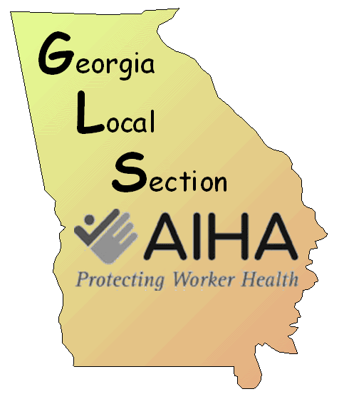
Fall Meeting Agenda

Kennesaw State University Small Business Development Center, Room 401
3333 Busbee Drive NW, Kennesaw

Thursday, November 10, 2016

8:00 AM – 8:30 A M | ARRIVAL, REGISTRATION (Breakfast will be served)
8:30 AM – 9:30 AM | OSHA Update  Keith Hass, Assistant Director, OSHA Atlanta West
 | BREAK
9:45 AM – 10:45 PM | IH Experiences in Railroads  Mark Dudle, Norfolk Southern
 | BREAK
11:00 – 12:00 | Zika  Charles Calmbacher, Consultant
 | LUNCH
1:00 – 2:00 | Lean and Safe  Damon Nix, Georgia Tech Enterprise Innovation Institute
 | BREAK
2:15 – 3:15 | IH in Electrical Utility  Brandon Cassidy, Georgia Power
 | BREAK
3:30 – 4:30 | IH in the Petroleum Industry  Stephen Bournias, Marathon Petroleum
4:30 | CLOSING

